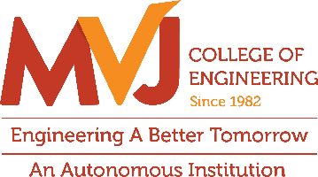
Department of ECE
Two-day hands-on workshop titled “Analog Design: From Fundamentals to Schematic Design, Layout Design, RC Extraction & Design Optimization”

The Department of Electronics and Communication Engineering (ECE), MVJ College of Engineering, successfully organized a two-day hands-on workshop titled “Analog Design: From Fundamentals to Schematic Design, Layout Design, RC Extraction & Design Optimization” on 5th and 6th October 2026 in Lab Room No. 158. The workshop was conducted by Mr. Kashyap V. Karun, Staff Analog Circuit Design Engineer, Samsung, who shared valuable industry expertise and practical insights into analog integrated circuit design.
The workshop attracted enthusiastic participation from 22 students, who actively engaged in the sessions to gain advanced knowledge and hands-on experience in analog VLSI design. The programme provided participants with an opportunity to bridge the gap between theoretical concepts and real-world industry practices, enabling them to develop a deeper understanding of analog circuit design methodologies and optimization techniques.
Through interactive demonstrations, practical exercises, and expert guidance, students were introduced to the complete analog design flow, including schematic design, layout design, RC extraction, and design optimization. The workshop served as an excellent platform for aspiring VLSI engineers to enhance their technical competencies and gain exposure to industry-relevant tools and processes.
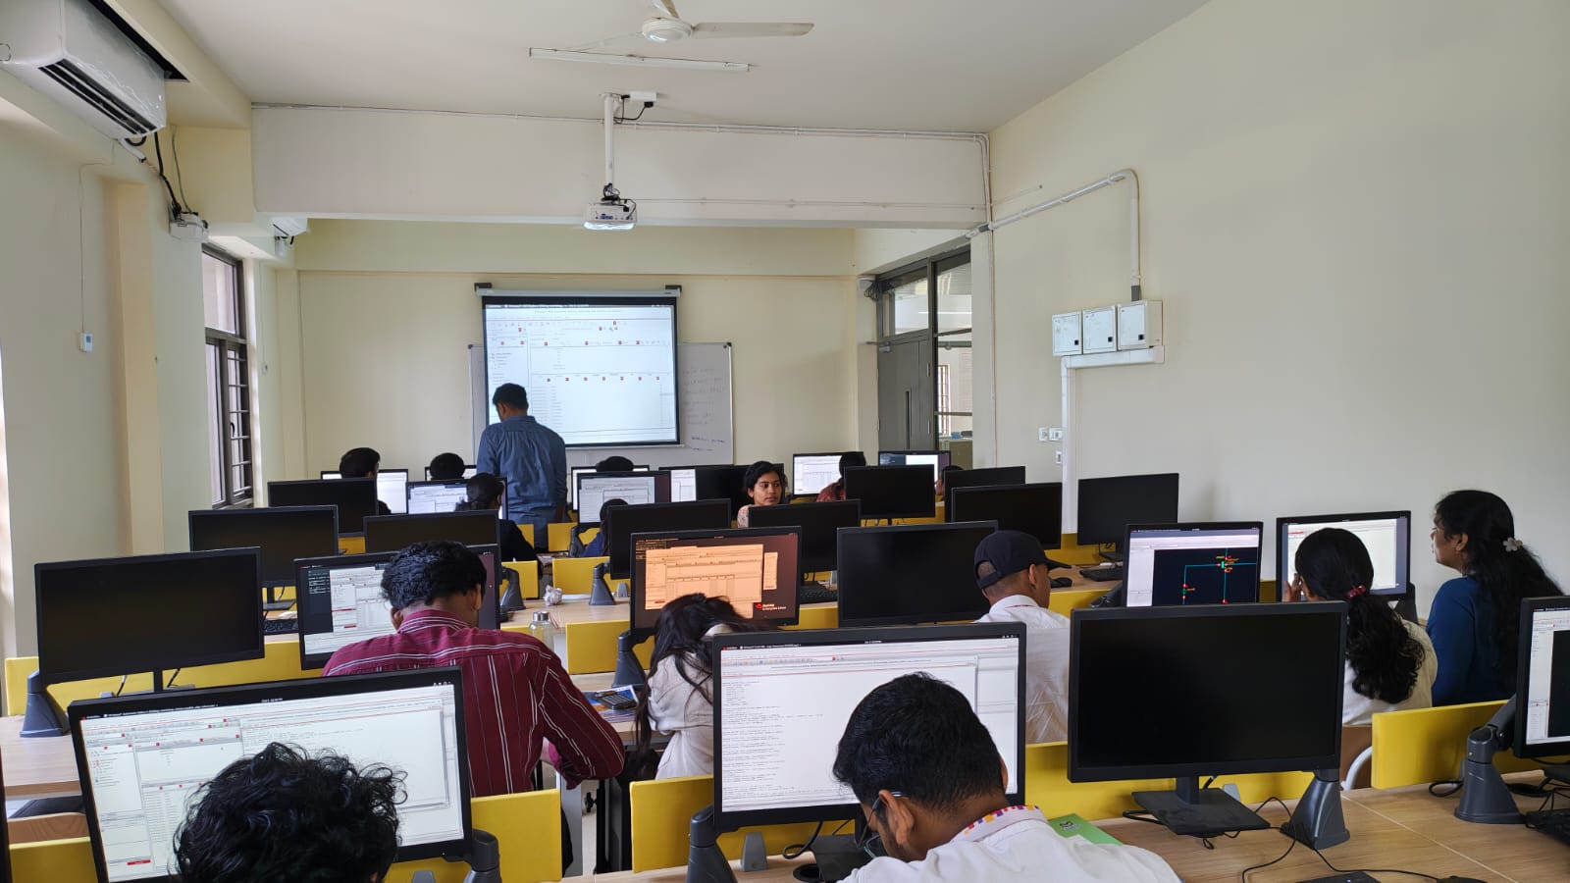

Interactive Learning Session on Analog IC Design by
Mr. Kashyap V. Karun during Day 1 of the Workshop

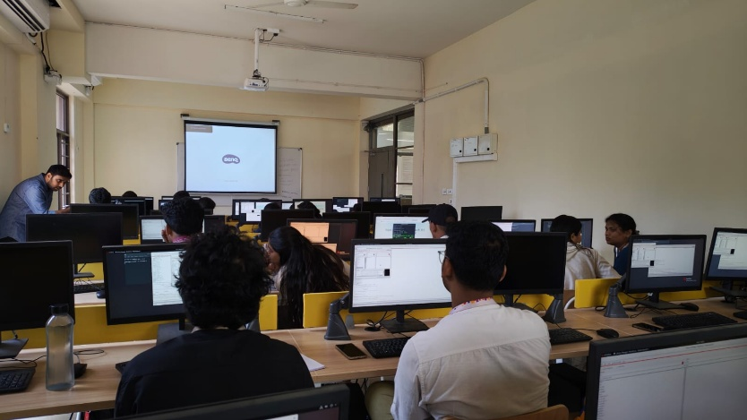

Interactive Analog IC Design Session Conducted by
Mr. Kashyap V. Karun during Day 2 of the Workshop

Program Highlights
The workshop provided participants with a comprehensive understanding of analog circuit design, beginning with the fundamentals of MOSFET operation, biasing techniques, transconductance, output resistance, overdrive voltage, and channel-length modulation. The sessions further explored advanced topics such as MOSFET small-signal analysis, current sources and mirrors, differential amplifiers with active loads, Common Mode Rejection Ratio (CMRR), and common-mode range configurations. Students were also introduced to inverter design, Low Noise Amplifier (LNA) architectures, Miller frequency compensation, and important stability parameters including poles, zeros, Unity Gain Bandwidth (UGB), phase margin, and gain margin. In addition to the theoretical sessions, extensive hands-on training was provided on Cadence Virtuoso, where participants performed DC, AC, transient, corner, and Monte Carlo simulations. The practical component also covered layout design methodologies, layout flow, parasitic RC extraction, design optimization, and post-layout verification, enabling students to gain real-world exposure to the complete analog IC design cycle.

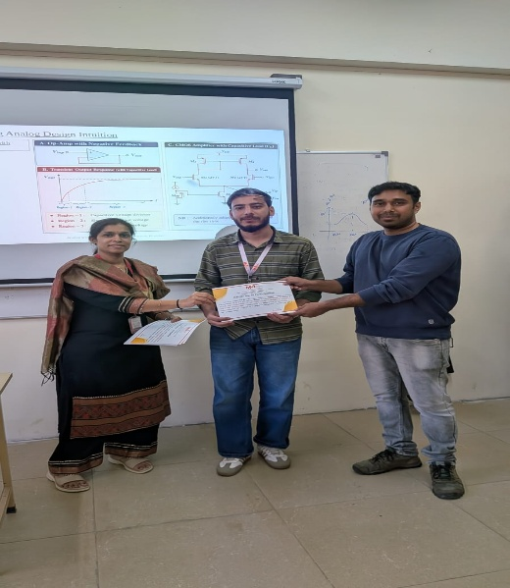
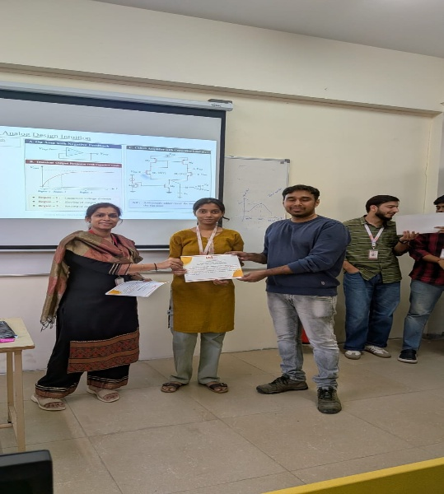

Certificate Distribution Ceremony with Dr. Shima Ramesh, Head of the Department of ECE, and Mr. Kashyap V. Karun, Resource Person, on the Concluding Day of the Workshop.

Outcomes and Impact
The workshop enhanced students’ understanding of analog IC design and industry-standard VLSI methodologies. Participants gained hands-on experience in Cadence Virtuoso, developing skills in circuit simulation, layout design, parasitic RC extraction, and design optimization. The programme bridged the gap between academic learning and industry practices, improving students’ readiness for higher studies and careers in the VLSI and semiconductor industries.
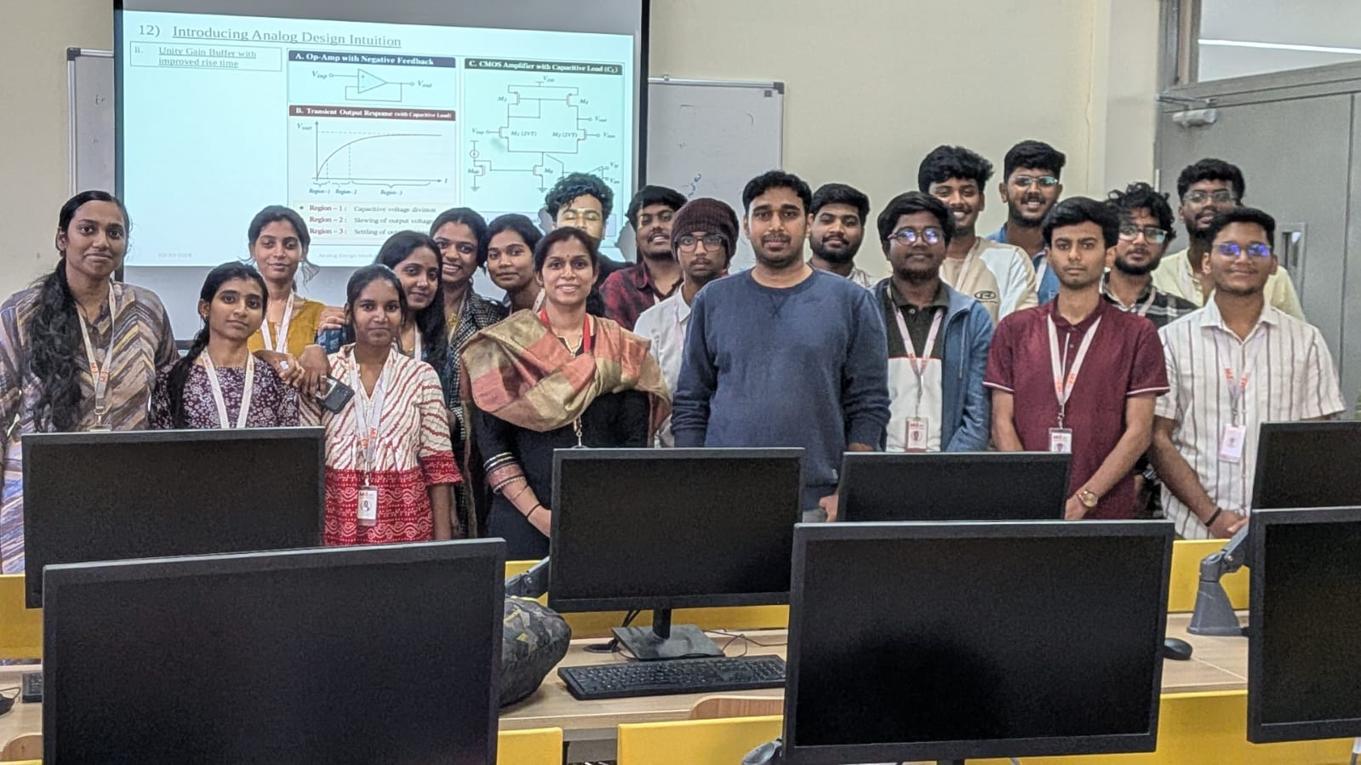

Workshop Participants with the Resource Person and HOD-ECE During the Valedictory Session.
Conclusion
The two-day Analog Design Workshop proved to be a highly enriching and impactful learning experience for the participants. By combining strong theoretical foundations with extensive practical training, the workshop enabled students to gain a holistic understanding of the analog IC design process. The expert guidance provided by Mr. Kashyap V Karun and the hands-on exposure to industry-standard tools empowered students with essential technical competencies required in the semiconductor industry. The workshop successfully fulfilled its objective of equipping aspiring engineers with the knowledge and skills necessary for advanced analog circuit design and future professional growth in the VLSI domain.

