
Department of ECE
Guest Lecture report on "AI-Driven Healthcare: From Digital Signal Processing to Intelligent Biomedical Diagnosis”

The Department of Electronics and Communication Engineering (ECE), MVJ College of Engineering, organized a guest lecture on “AI-Driven Healthcare: From Digital Signal Processing to Intelligent Biomedical Diagnosis” on 26 September 2026 at the Dr. M. V. Jayaraman Auditorium. The session was delivered by Mr. Vinay Hebbatam, Senior Principal AI Engineer, LifeSignals Group, and attended by around 350 students. The guest was welcomed by Dr. Shima Ramesh Maniyath, Head of the ECE Department. The lecture provided valuable insights into the applications of Digital Signal Processing (DSP) and Artificial Intelligence (AI) in modern healthcare and biomedical diagnosis.
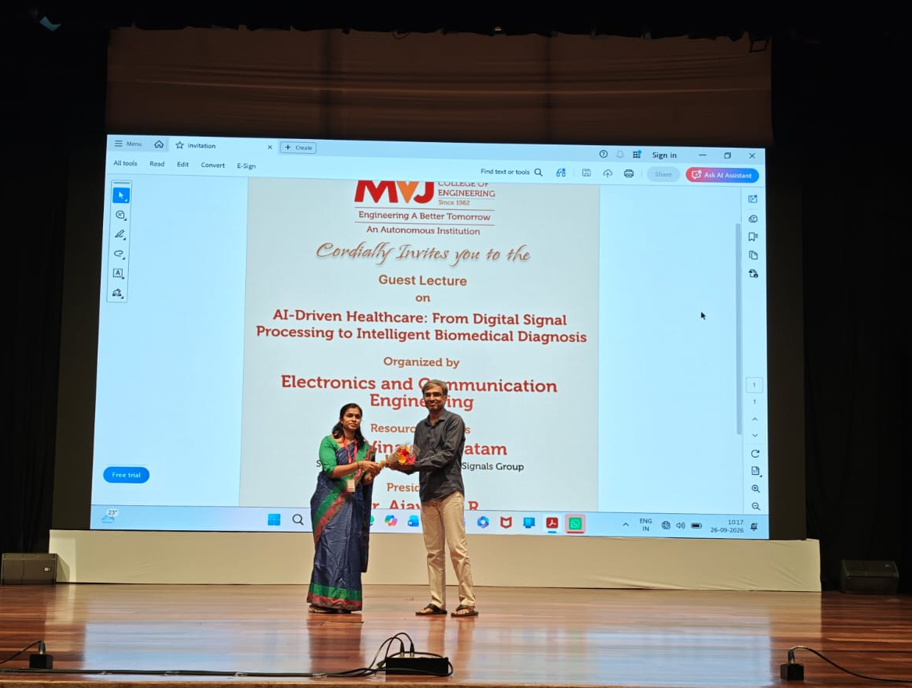
Dr. Shima Ramesh, Head of the Department of ECE, welcoming the resource person Mr. Vinay Hebbatam (Senior Principal AI Engineer, LifeSignals Group) with a bouquet during the guest lecture on AI-Driven Healthcare

The session aimed to bridge the gap between theoretical Digital Signal Processing (DSP) concepts and their practical applications in healthcare. It helped students understand the integration of DSP and Artificial Intelligence (AI) in biomedical systems, apply concepts such as DFT, FFT, FIR, and IIR filtering to signals like ECG and EEG, and gain insights into machine learning techniques for disease detection and signal classification.
The resource person also discussed real-world applications of AI in intelligent patient monitoring and computer-aided diagnosis, while highlighting emerging research and innovation opportunities in healthcare technology. Key topics covered included biomedical signal acquisition and preprocessing, ECG and EEG signal analysis, digital filtering techniques, AI-based signal classification, and case studies on intelligent healthcare monitoring and AI-assisted disease diagnosis.

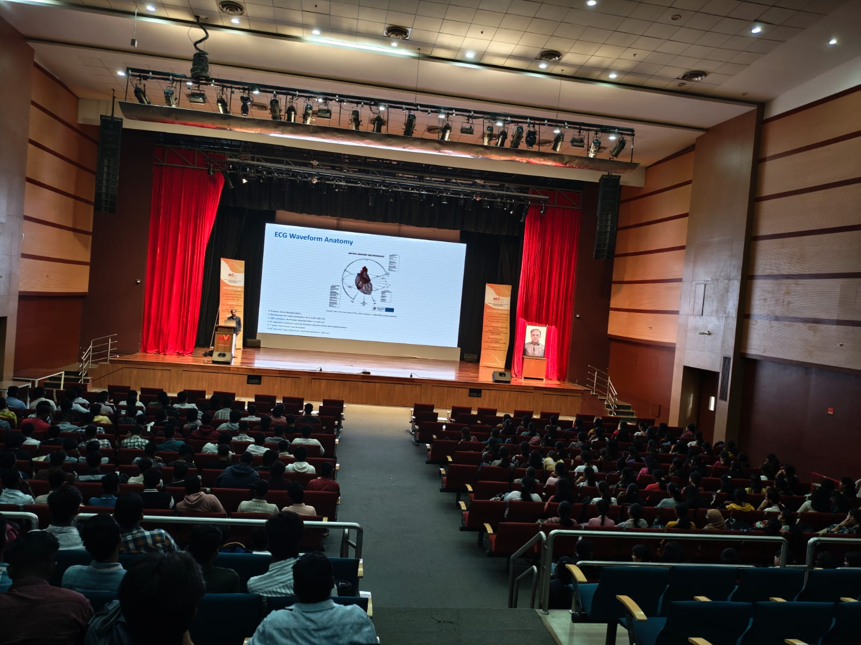
Guest Lecture on AI-Driven Healthcare by Mr. Vinay Hebbatam, organized by the Department of ECE.
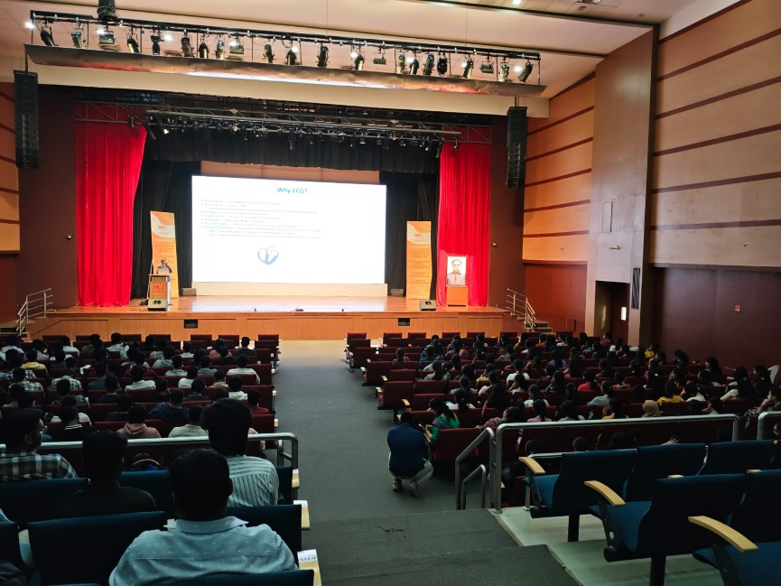
Empowering the Future of Healthcare: ECE Department's Guest Lecture on AI-Driven Biomedical Diagnosis led by Mr. Vinay Hebbatam, Senior Principal AI Engineer, LifeSignals Group.

Outcomes and Impact
The guest lecture significantly enhanced students’ understanding of the application of Digital Signal Processing (DSP) and Artificial Intelligence (AI) in healthcare. Participants gained insights into the use of DFT, FFT, FIR, and IIR filtering techniques for analyzing biomedical signals such as ECG and EEG. The session also familiarized students with AI and machine learning approaches for signal classification, disease detection, and intelligent patient monitoring. Exposure to industry practices and emerging research trends helped bridge the gap between classroom learning and real-world healthcare applications.
Conclusion
The guest lecture on “AI-Driven Healthcare: From Digital Signal Processing to Intelligent Biomedical Diagnosis” was highly informative and successful in connecting theoretical concepts with practical healthcare applications. Through expert insights from Mr. Vinay Hebbatam, students gained valuable knowledge of AI-enabled biomedical diagnosis, signal processing techniques, and intelligent patient monitoring systems. The session broadened their understanding of emerging technologies and inspired them to explore research and career opportunities at the intersection of electronics, AI, and healthcare.

