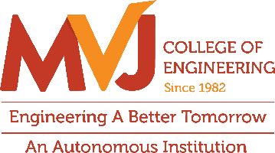
Department of ECE
Industrial Visit to ISR0 RRSC

On September 30, 2026, the Department of Electronics and Communication Engineering at MVJ College of Engineering organized an educational industrial visit to the Regional Remote Sensing Centre (RRSC), ISRO, specifically tailored for 7th-semester undergraduate students. A total of 62 students, accompanied by three faculty members, arrived at the ISRO-RRSC at 9:20 AM.
The primary objective of this visit was to bridge the gap between theoretical classroom learning and real-world engineering applications in space-based systems, satellite communication, and advanced Earth observation technologies
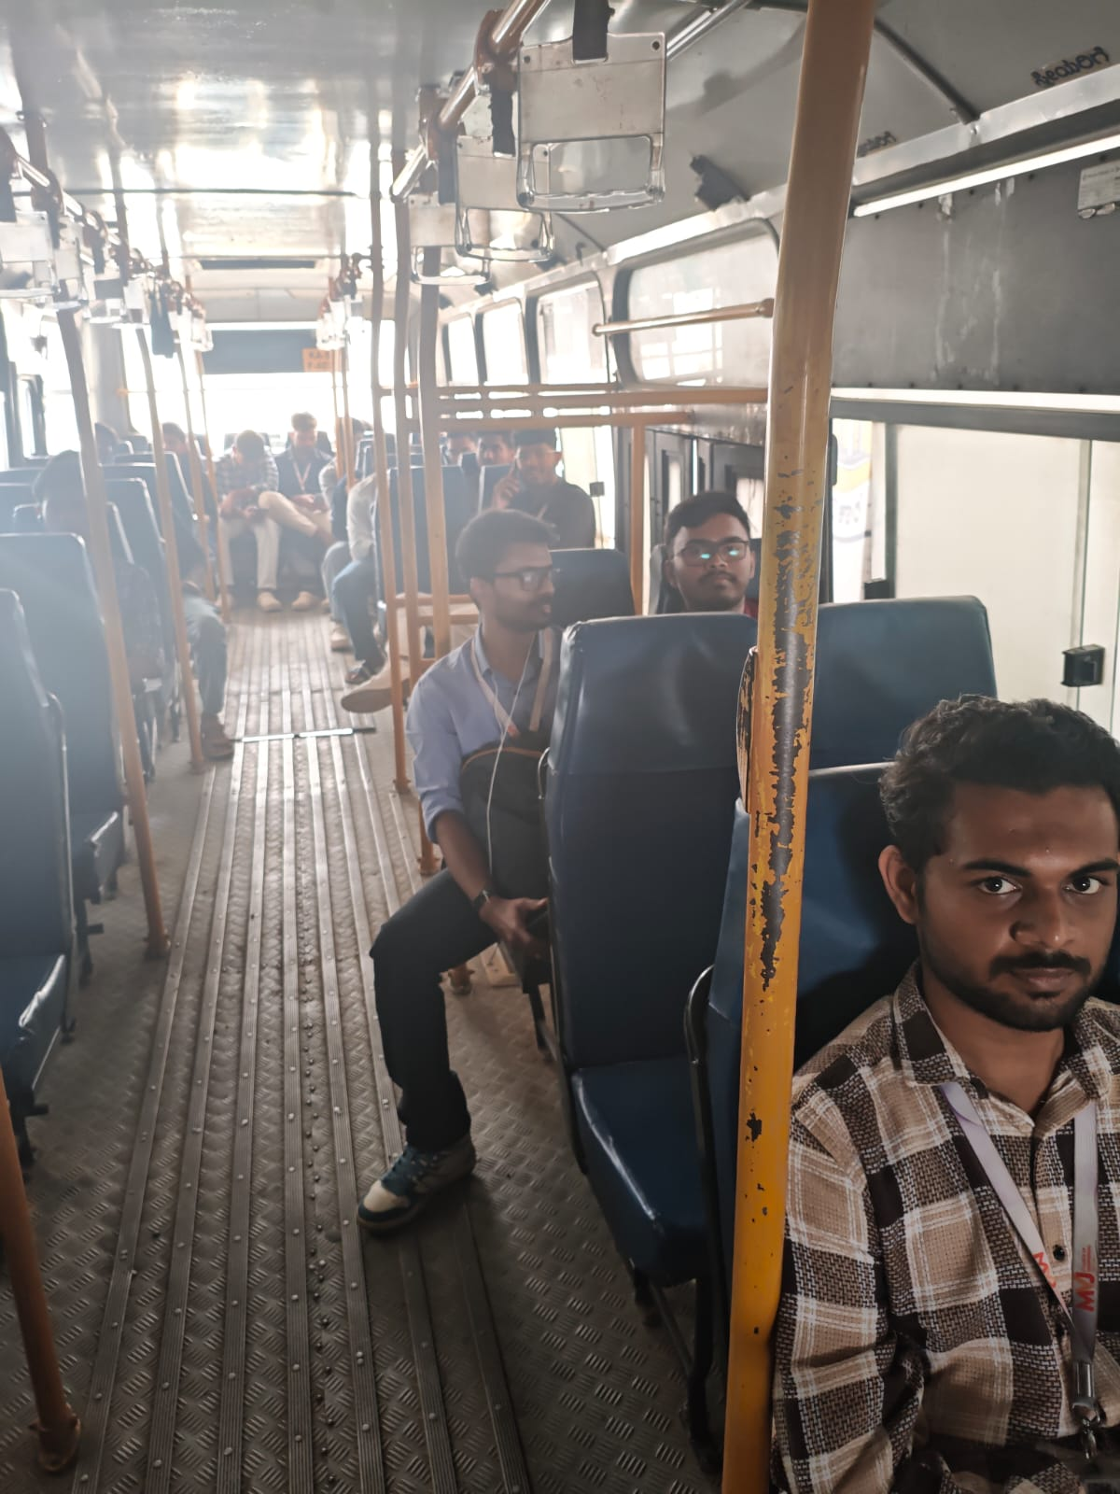
Students heading to ISRO-RRSC for an exciting learning experience

Program Highlights
During the visit, students and faculty members received comprehensive technical exposure to advanced space systems and Earth observation technologies. The program featured in-depth sessions on remote sensing applications, satellite communication, and Geographical Information Systems (GIS), showcasing how satellite payloads capture high-resolution imagery for natural resource management, weather forecasting, and disaster management support. Attendees also gained direct insight into ground station operations, data processing workflows, and telemetry systems. Furthermore, interactive discussions with ISRO scientists and engineers provided valuable clarity on real-world engineering challenges, bridging classroom concepts with practical aerospace innovations and inspiring students toward future careers and technical projects in the space sector.
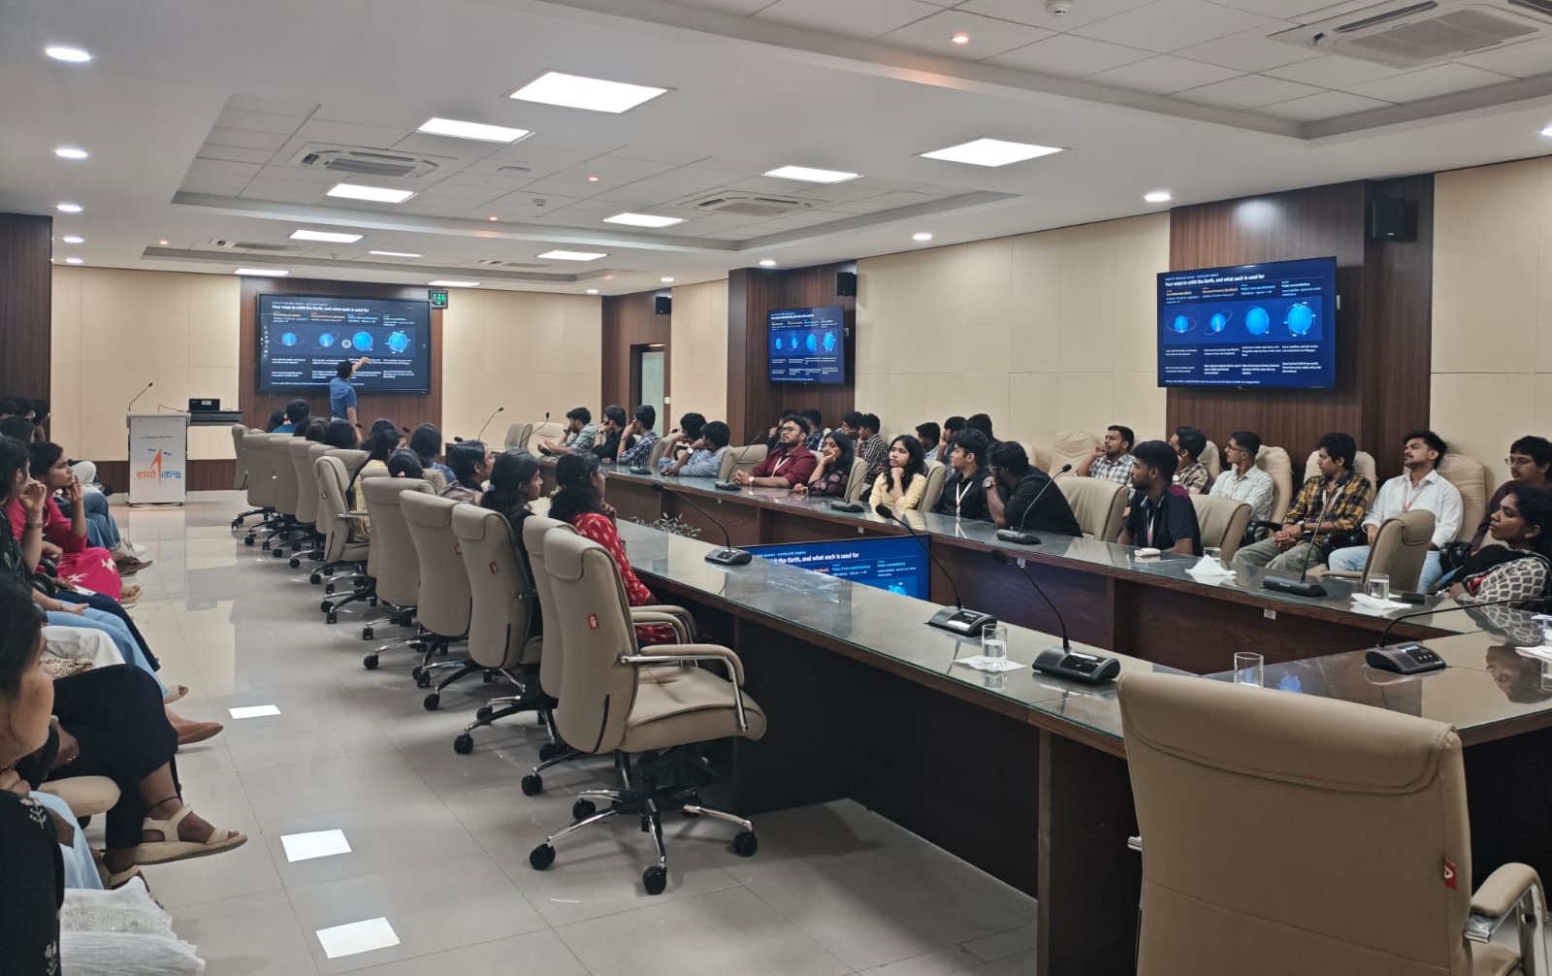

Students attentively engaged in the informative session at ISRO-RRSC, gaining insights into satellite technology, remote sensing, and space research.

Outcomes and Impact
The industrial visit proved to be an immensely enriching experience for the final-year ECE students, yielding key academic and professional outcomes by helping students correlate core subjects like digital communication, signal processing, and electromagnetic fields with operational space systems. Additionally, it motivated students to incorporate real-world space engineering problem statements into their final-year capstone projects while enhancing their understanding of professional research standards, national technological infrastructure, and collaborative engineering environments.
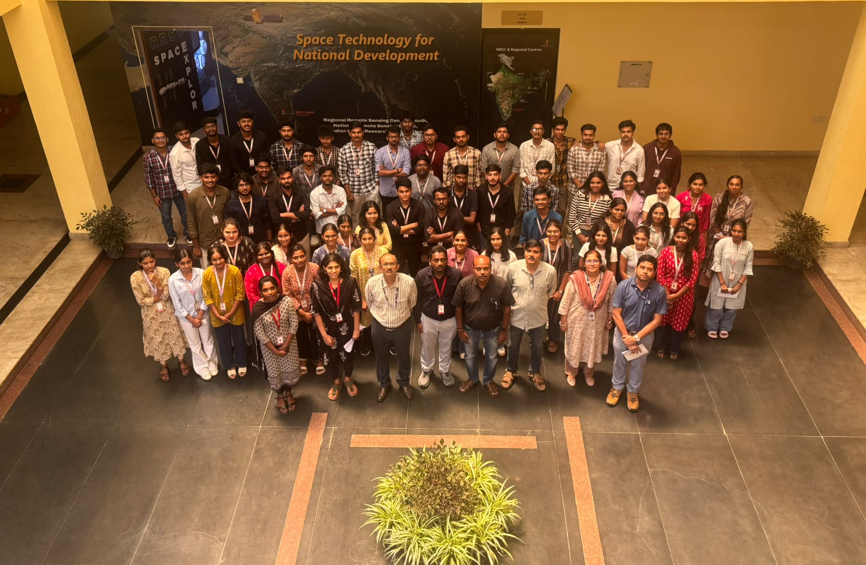
A memorable group photo capturing the enriching industrial visit to ISRO-RRSC, where learning met inspiration in the realm of space exploration.

Conclusion
The industrial visit to ISRO RRSC was a resounding success, offering 7th-semester ECE students a rare window into premier space research operations. The Department of Electronics and Communication Engineering expresses its profound gratitude to the management of MVJ College of Engineering for their continued encouragement and extends heartfelt thanks to the scientists and administrative authorities at ISRO RRSC for hosting the delegation and providing a deeply inspiring learning experience.

