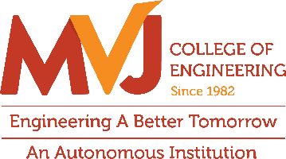

Department of ECE

E-FORZA Club Activity report on SIGNAL QUEST – Decode the Wave. Discover the Message
The Department of ECE successfully organized an engaging E-FORZA club activity titled "SIGNAL QUEST – Decode the Wave. Discover the Message" on September 26th , 2026 at 1.30 pm to 4.30 pm at 342 Lab of ECE Department. Structured as a competitive two-round challenge, the event was designed to test and reinforce students' practical understanding of signal processing concepts, encourage analytical thinking in decoding complex wave signals, and foster competitive problem-solving and teamwork. The participants' performances and final outcomes were evaluated by industry expert Mr. Vinay Hebbatam, Senior Principal AI Engineer at LifeSignals Group, providing students with valuable professional assessment and bridging academic learning with real-world technical standards.
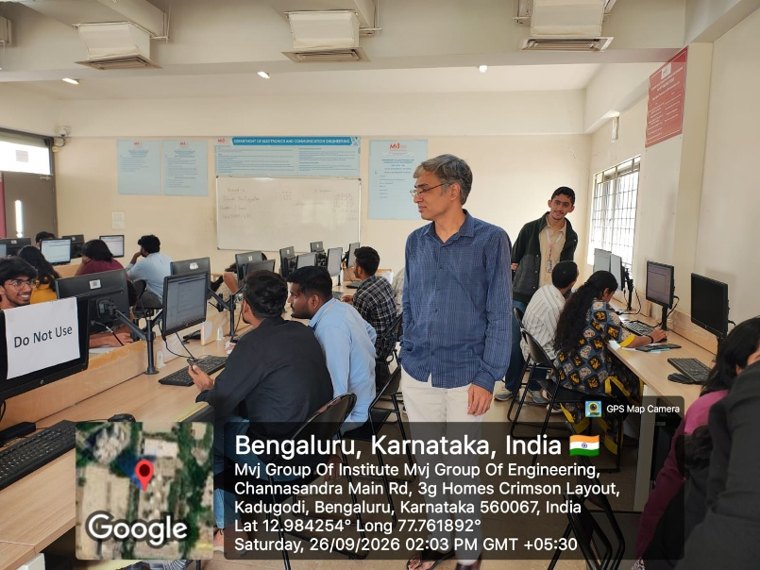
Mr. Vinay Hebbatam, Senior Principal AI Engineer at LifeSignals Group, evaluating participants' performances as the judge for the "SIGNAL QUEST – Decode the Wave" E-FORZA club activity

Objective
The objectives of the "SIGNAL QUEST – Decode the Wave. Discover the Message" E-FORZA club activity were to test and reinforce students' practical understanding of signal processing concepts through engaging, interactive challenges, encourage analytical thinking by developing participants' abilities to decode, analyze, and interpret complex wave signals, foster competitive problem-solving skills and teamwork among students in a dynamic club environment, and provide an interactive evaluation platform judged by an industry expert to successfully bridge academic learning with real-world technical assessment standards.
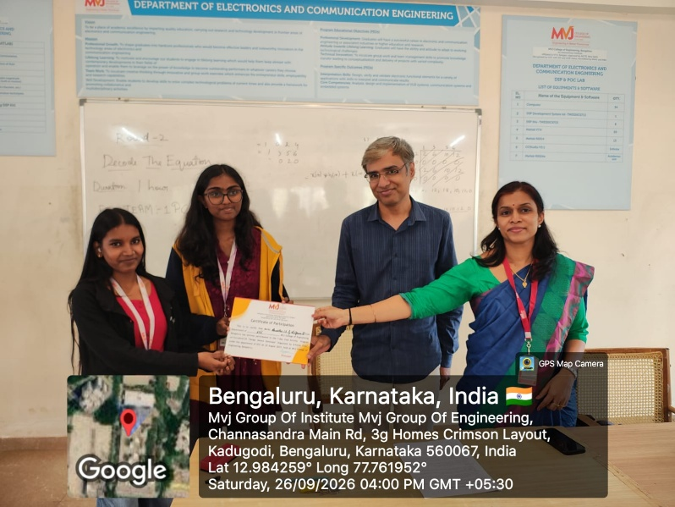
Mr. Vinay Hebbatam and Dr. Shima Ramesh, Head of the Department of ECE, presenting certificates to the winners of the "SIGNAL QUEST – Decode the Wave" club activity

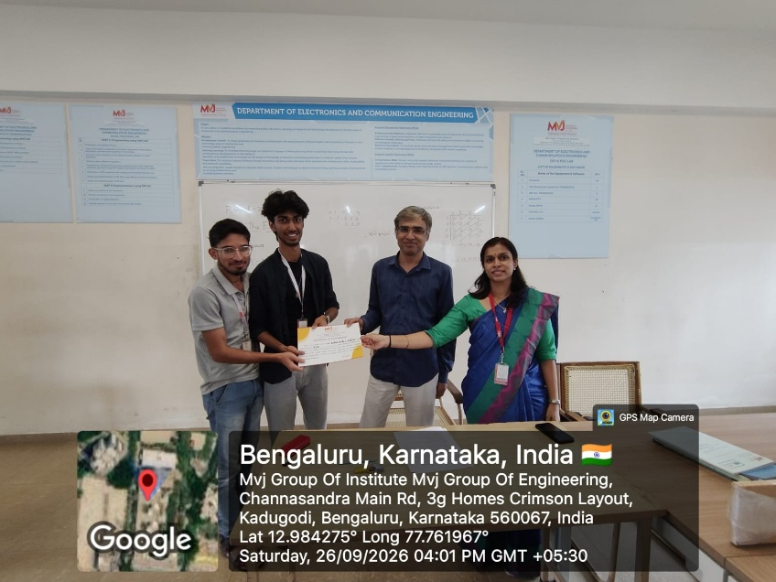
Mr. Vinay Hebbatam and Dr. Shima Ramesh, Head of the Department of ECE, presenting certificates to the runners of the "SIGNAL QUEST – Decode the Wave" club activity.
Conclusion
Structured as a competitive two-round challenge, around 32 students participated in the session. The participants' performances and final outcomes were evaluated by industry expert Mr. Vinay Hebbatam, Senior Principal AI Engineer at LifeSignals Group, providing students with valuable professional assessment and bridging academic learning with real-world technical standards. To celebrate their efforts, certificates were awarded to the winners by Mr. Vinay and Dr. Shima, Head of the Department of ECE, while certificates were also distributed to the coordinators and participants.
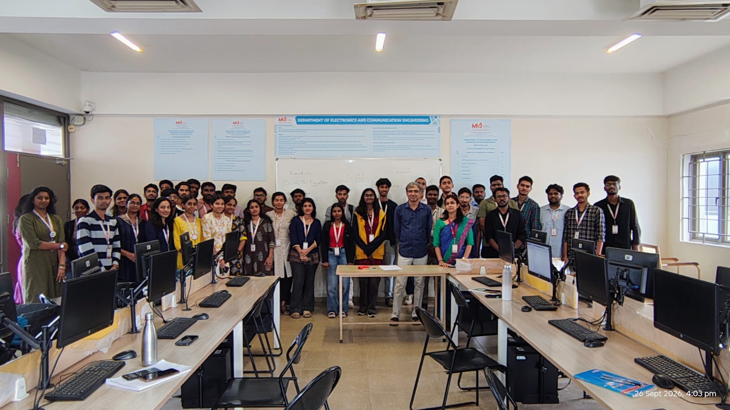
A memorable group snapshot capturing the enthusiasm of all participants and winners at the E-FORZA club's "SIGNAL QUEST" event, joined by guest expert Mr. Vinay Hebbatam and HOD Dr. Shima Ramesh

